Information ***
Submitted by

***

***
A disease is a particularly strange condition that influences the construction or capability of an organic entity in entire or to a limited extent and isn't brought about by a quick outside injury. It is widely known that sicknesses are ailments described by specific signs and side effects.
Some of the common disease incorporate HIV, influenza, measles, Coronavirus, strep throat, and salmonella. Noninfectious sicknesses incorporate Alzheimer's infection, diabetes, malignant growth, and congestive cardiovascular breakdown.
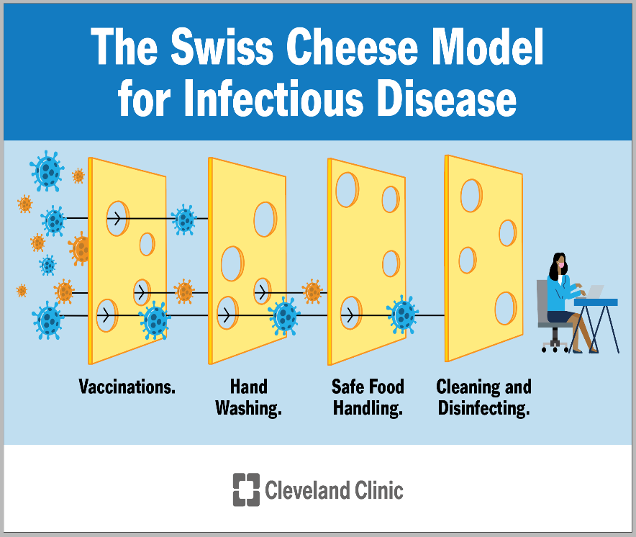

AC 2.1: Difference *** *** and Non-*** ***
*** *** | Non-*** ***
*** which have potential to be passed from one entity to another by means of air, matter, or water. | Infections that can't be passed starting with one individual then onto the next through contact, air, water, or some other means are viewed as non-communicable.
Bacteria, viruses, and other infectious agents are to blame for these, which are highly contagious. | They are not caused by any infectious agent and are not infectious.
It is impossible to pass on these diseases. | It is possible to pass on these illnesses.
They are contagious in nature. | They are non-contagious in nature.
These diseases can be treated by conventional methods. | These are treated by medicines and surgeries.
Examples of *** disease are tuberculosis, Common Cold and AIDS. | Examples of Non-*** *** include heart disease and diabetes.
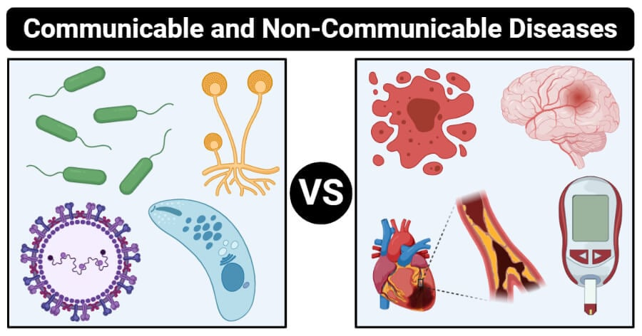

AC 2.2: Biological *** of Non-*** ***
Effective interventions addressing shared modifiable behavioral risk factors can largely prevent the main NCDs. The shared behavioral risk factors that can be changed are responsible for two thirds of these premature deaths: unhealthy diets, physical inactivity, tobacco use, and harmful alcohol consumption. Key metabolic and biological changes that increase the risk of NCDs are caused by these unhealthy behaviors: hyperlipidemia, which refers to a high level of fat in the blood, high blood glucose levels, diabetes, and obesity (Habib and Saha, 2010).
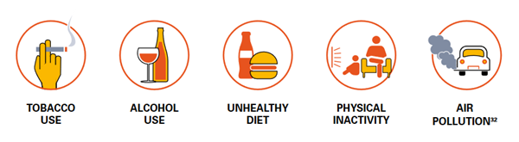

How *** Cell *** ***

*** cell disease is a blood disorder that can be acquired. Hemoglobin deficiency is a description of it. It is this protein, which is found in red platelets, that carries oxygen to the body's tissues. Therefore, sickle cell disease prevents oxygen from reaching the tissues.

The typical hemoglobin red platelet is smooth, shaped like a circle, and flexible, like a doughnut without a hole. They go through the veins efficiently. Hemoglobin-positive cells in sickle cells are rigid and unattractive. These cells form a sickle or bow shape, resembling the letter C, when they lose oxygen because they stay together and can only move through the veins with great effort. This may impede the flow of regular, solid blood carrying oxygen through tiny veins. The obstruction could be upsetting.

The life expectancy of ordinary red platelets is as long as 120 days. Notwithstanding, sickle cell illness just endures somewhere in the range of 10 and 20 days. Moreover, the spleen might obliterate sickle cells because of their firmness and shape. Contaminations are taken out from the blood by the spleen. In this channel, sickle cells become stuck and pass on. An individual might foster persistent frailty on the off chance that their body has less solid red platelets. The spleen is likewise hurt by the sickled cells. Thus, contamination risk increments (Barouki et al., 2012).
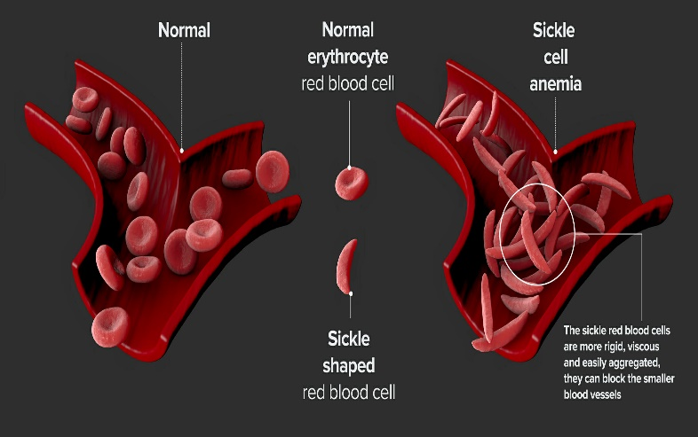

How *** Type 2 *** ***
Type 2 *** can cause following illness and infections:
Infections of the ear, nose, and throat: *** patients almost always experience fungal infections of the nose and throat. Ear discharge and severe ear pain are symptoms.
Infections of the urinary tract (UTIs): One of the main causes of UTIs is diabetes that isn't under control. Germs like Escherichia coli, Klebsiella, Enterococcus, and Candida frequently cause these UTIs. Infections of the kidney and bladder inflammation are also common.
Infections of the skin and soft tissue: *** increases the likelihood of leg infections and wounds (also known as diabetic foot). These infections can be brought on by repeated trauma and unsuitable footwear. Amputation may be necessary if these infections are not treated promptly and appropriately (Beaglehole et al., 2011).
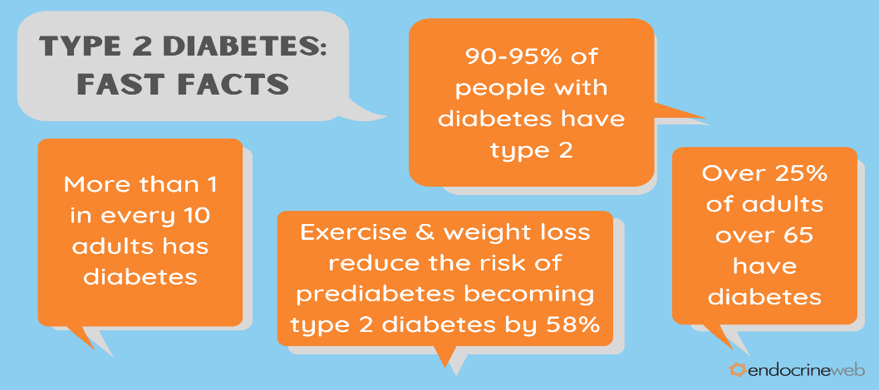

Prevention from Non-*** ***
Reduce premature death and disability caused by NCDs by promoting a healthy diet, engaging in physical activity, reducing alcohol consumption, and quitting tobacco use are simple and cost-effective measures. Non-communicable diseases (NCDs) and their burdens, as well as the risk of developing co-morbidities with other illnesses, can all be mitigated and reduced through effective prevention strategies.

References
Habib, S.H. and Saha, S., 2010. Burden of non-communicable disease: global overview. *** & Metabolic Syndrome: Clinical Research & Reviews, 4(1), pp.41-47.
Barouki, R., Gluckman, P.D., Grandjean, P., Hanson, M. and Heindel, J.J., 2012. Developmental origins of non-communicable disease: implications for research and public health. Environmental Health, 11(1), pp.1-9.
Beaglehole, R., Bonita, R., Horton, R., Adams, C., Alleyne, G., Asaria, P., Baugh, V., Bekedam, H., Billo, N., Casswell, S. and Cecchini, M., 2011. Priority actions for the non-communicable disease crisis. The lancet, 377(9775), pp.1438-1447.

