King Fahd University of Petroleum & Minerals  College of Engineering Sciences  Mechanical Engineering Department | 

Coop Training Program

“The National Energy Services Company - Tarshid”

Progress Report

(Retrofitting Buildings)

Submitted to

Coop Advisor: Dr. Al-Qahtani, Mohammed S

Coop Coordinator: Dr. Mohamed Antar

Prepared by xxx Ahmed Almadani xxx

Name | Family Name |  |  |  |  | First Name
 | Almadani |  |  |  |  | Ahmed
KFUPM ID#: | 2 | 0 | 1 | 7 | 4 | 7 | 1 | 1 | 0

Submission Date: | (dd) |  | (mm) |  | (yyyy)
 | 0 | 7 | 0 | 4 | 2 | 0 | 2 | 2

Summary

This report will introduce a full description of training organization, the department I have worked with and our activities and a complete discussion of two case studies I have done in my cooperative training program with the National Energy Services Company (TARSHID) during the period from January 16th, 2022, to August 11, 2022. The department I have worked with is the project management department which is responsible for managing assigned projects from the biggening until the hand over to the entities following proper steps.

Acknowledgement

In this report, I have put in a lot of effort. Regardless, it would not have been possible without the tremendous assistance of many people and organizations. I'd want to express my heartfelt gratitude to each and every one of them.

I'd want to convey my heartfelt gratitude to everyone who helped me finish this report and offered me the opportunity to work at Tarshid. I have a special appreciation for my coop guides at KFUPM, and Tarshid Mohammed Al-Qahtani and Saleh Abuhaimed, whose dedication to providing energizing recommendations and support assisted me in connecting my mechanical engineering research to real-world work and applications.

Likewise, I want to express my gratitude to Tarshid's execution and operations team, who granted me permission to use the necessary hardware and permissions to complete my coop program, notably Eng. Abdullah Johani, who was extremely helpful. Exceptional thanks also goes to Eng. Turki Hussein, who assisted me much with electrical related issues.

List of Abbreviations and Symbols

ESCO: Energy Service Company
JOBEX: Job explanation meeting
RFP: Request for Proposal
ESM: Energy saving measures
M&V: Measurement and Verification
O&M: Operation and Maintenance
BMS: Building Management System
HVAC: Heating, Ventilation, and Air Conditioning
PMT: Project Management Team
COO: Chief of Operations

Chapter 1

Introduction to coop Activities

Introduction:

This is the first progress report in my coop training program that is coordinated by Tarshid associated with the KFUPM Training Department. As ME Department planned, this report should be submitted after ten weeks from the starting day. The COOP Plan and the tasks to be completed are mentioned in detail in this report. Also, it includes the tasks completed during the first ten weeks.

Company profile:

Tarshid is the National Energy Services Company, recently established by the Public Investment Fund to catalyze the development of a more energy efficient Saudi Arabia. The launch of Tarshid is a result of a collaborative effort between the Ministry of Energy, Ministry of Finance, and the Saudi Energy Efficiency Center. Tarshid aims to be a pioneer in the energy efficiency field and to build towards a more sustainable future. Tarshid has a mandate to develop, fund and manage impactful energy efficiency projects in government and commercial sectors that achieve significant energy savings for the Kingdom.

Company organization:
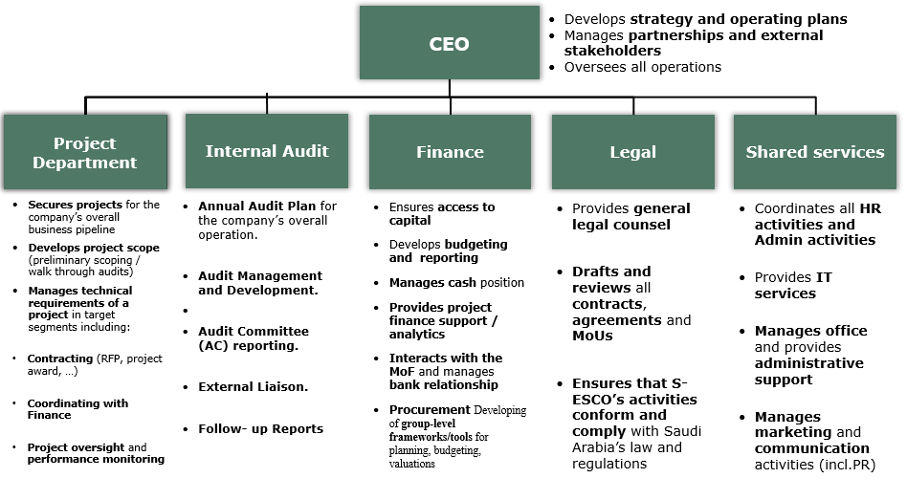
The company organization to deliver its objectives can be best described with the matrix below.

Safety issues in the workplace:

TARSHID is particularly concerned on safety and environmental issues. They conducted several safety sessions and workshops throughout the training to familiarize their trainees as well as remind their employees of safety rules and emergency procedures by distributing the Safety pamphlet and spreading awareness among the public on how to deal with any problem that may arise at work. Tarshid places a high focus on the safety of their employees and trainees because any risky behavior or risks at work might have disastrous repercussions. In the event of a fire, for example, RACE and Evacuation procedures must be
Followed.

R RESCUE Removing people from immediate danger is top priority.
A ALARM Alarm the building fire alarm and alert others.
C CONFINE Confine the fire by closing the windows.
E EVACUATE Use fire extinguisher if you can do it safely, if not evacuate.

Evacuation instructions:
- Never use elevators to evacuate the building in case of fire.
- Follow the emergency exit signs and evacuate from the nearest exist.
- Gather at designated assembly area and wait for further instructions.
Do not re- enter the building until emergency response officials have declared that it is safe to do so.

Coop plan (in the appendix):

For the coop plan, I started with attending sessions with the technical team explaining the ESMs of Tarshid such as Lighting replacement, lighting control, BMS and HVAC system. Then after that I started handling some managing responsibilities as shown in the appendix.

Discrepancy from the coop plan activities:

Due to some family emergency I had to have the coop in Jeddah, so I asked the company during the interview that I intend to work in Jeddah, and they agreed. but due to the delay of some paperwork regarding the projects in Jeddah they asked me to stay in Riyadh for a couple of months. That is why my coop plan might change when I transfer again to Jeddah.

Chapter 2

Theoretical Background

2.1. Introduction:

Nowadays, big buildings have multiple mechanical systems that make life easier, such as plumbing, elevators, escalators, and heating and air-conditioning systems. Retrofitting buildings requires a lot of Energy saving methods related to mechanical engineering. One of the most important systems which provide air conditioning to big building is called chiller system

Theoretical Background:

Commercial buildings use Heating, Ventilation and Air Conditioning (HVAC) systems to dehumidify and to cool the building. Chillers have become an essential HVAC component of a wide variety of commercial facilities, including hotels, restaurants, hospitals, sporting arenas, industrial and manufacturing plants, etc. The industry has long recognized that chiller systems represent the single largest consumer of electrical usage in most facilities.

2.2.1 What are Chiller Systems

in general, a chiller facilitates the transfer of heat from an internal environment to an external environment. This heat-transfer device relies on the physical state of a refrigerant as it circulates through the chiller system. Certainly, chillers can function as the heart of any central HVAC system.

2.2.2 How Does a Chiller Work

A chiller operates on the vapor compression or vapor absorption concept. Chillers maintain a constant coolant flow to the cold side of a process water system at a temperature of around 50°F (10°C). The coolant is then pumped through the process, extracting heat from one portion of the facility and returning it to the process water system return side.

A chiller is a mechanical refrigeration system that uses vapor compression and connects to the process water system via an evaporator. A chiller's evaporator, compressor, condenser, and expansion device are all devices the refrigerant circulate through. Each of the chiller's above components undergoes a thermodynamic process. The evaporator acts as a heat exchanger, transferring heat from the process coolant flow to the refrigerant. The refrigerant evaporates, transforming from a low-pressure liquid to vapor, as the heat transfer occurs, and the temperature of the process coolant decreases.

The refrigerant is then directed to a compressor, which performs a variety of tasks. To begin, it removes refrigerant from the evaporator and ensures that the evaporator's pressure is low enough to absorb heat at the proper pace. Second, it increases the pressure in the departing refrigerant vapor to guarantee that the temperature of the vapor remains high enough to release heat when it reaches the condenser. At the condenser, the refrigerant reverts to a liquid condition. A cooling medium transports the latent heat released when the refrigerant transitions from vapor to liquid away from the environment.
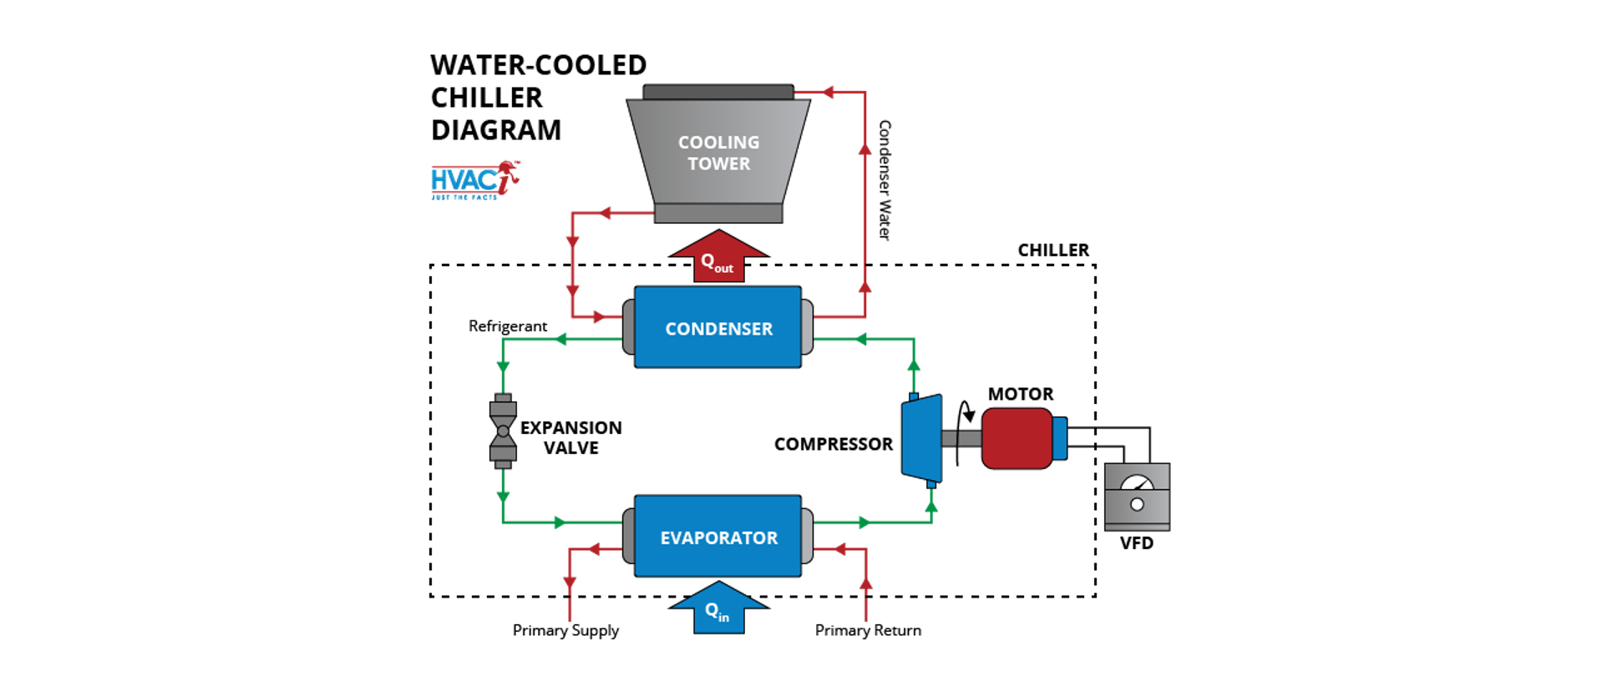

Chapter 3

Work Activities and case studies

Introduction:
Tarshid manages and funds the upgrade and replacement of energy equipment in buildings and public facilities, on an exclusive basis for government entities and on a competitive basis for commercial ones. We contract ESCOs to execute, operate and maintain retrofit projects, and recoup realized energy savings as a return on our investment. We enable building owners to reduce their energy bills and achieve their sustainability objectives without necessarily investing their own capital.

Tarshid project department provides a broad range of services for clients who wish to fund their own retrofits, such as tendering retrofit projects including the development and issuance of RFPs, ESCO identification and selection, energy savings measures assessment, and overall tendering process management. Also, it Reviews and evaluate energy efficiency feasibility studies and offer supervisory support for the execution of energy efficiency measures. Finally, we provide Measurement and Verification support on a regular basis, to assess and validate actual savings achieved.

3.2 Main activities
During the period of the training, I have completed I worked as a member of Project Management Team (PMT). Most project teams require involvement from more than one department; therefore, I interacted with different departments such as the technical department, O&M department and finally the M&V department. As a member of the PMT you need to have the right combination of skills, abilities, and personality types to achieve collaborative tension.

One of the main activates I did in the biggening was site visits. As a PMT member we were assigned to visit different sites of the project frequently. Those visits are assigned to us to be able to familiarize and understand the job nature technically. In each site visit I had to get familiar to several devices and machines and make comments on my own notebook. We also need to keep track with the ESCOs handling the projects so we can monitor their performance and be sure that they are committing to the contract between us.

Also, I attend a weekly progress meeting every Sunday with our team senior portfolio manager, and another weekly meeting each Wednesday with the COO, and finally a monthly meeting with the CEO.
Finally, I was Engaging with ESCOs to receive project bids at the JOBEX and conduct an on-field technical walkthroughs to assess viability of projects and providing go/no-go decision.

Appendix1: coop plan
 | National Energy Services Company (Tarshid)

APPLIED MECHANICAL ENGINEERING
(AME) COOP WORK PLAN

SECTION (A):
Information about the student and the Company

The student | KFUPM ID #: | 201747110
 | Name (Family Name, First Name): | Almadani, Ahmed
 | E-mail Address: | S201747110@kfupm.edu.sa
 | Mobile Phone: | 0547274741
 | KFUPM Coop Advisor: | Dr. Al-Qahtani, Mohammed S
 | Academic Advisor: | Dr. Mohammed Antar
 | Training Period: | From | To
 |  | (16/01/2022) | (11/08/2022)

ME Coop Coordinator | KFUPM ME Coordinator: | Dr. Mohammed Antar
 | Tel.: | (013)-860-2964
 | E-mail: | antar@kfupm.edu.sa

The Company | Company Name: | National Energy Services Company (Tarshid)
 | Location: | Riyadh
 | Website of the Company: | www.tarshid.com.sa
 | Training Department/Division: | Operation
 | Supervisor/Mentor Name: | Mohammed AlTamimi
 | E-mail Address: (Supervisor) | mohammed.tamimi@tarshid.com.sa
 | Mobile: (Supervisor) | 05049800492

SECTION (B): OBJECTIVES

Writing a training objective correctly ensures that all parties understand what the student is to be working towards. A well written objective will provide clarity in terms of what the student should be learning and how well they should be performing the task.

Objectives:

- RFP Technical Datasheet (ASHREA level-I Audit Report)
  - Surveying data validation
  - Potential ESMs assessment
- Technical Proposal (ASHREA level-II Audit Report)
  - Technical evaluation
- Detailed Facilities Study (ASHREA level-III Audit Report)
  - Energy Saving Calculation
  - Measurement and Verification Plan
- Energy Saving Procurement Contract
- Energy Efficiency Project Management processes

SECTION (C): Training Program Outline

Kindly provide the key training elements/focus areas that the Company will assign the student, indicating the length of time, major department rotations, if applicable: (you may combine weeks)

Training Period |  |  | Department Name | Tasks:  Please indicate if individual work assignments or team assignments will be made
Week # | From  (DD/MM/YYYY) | To  (DD/MM/YYYY)
 | 16/01/2022 | 03/02/2022 | Project Management | Lighting /BMS/HAVC/ sessions with Tarshid technical team
 | 06/02/2022 | 24/02/2022 | Project Management | Project walkthrough KSU PSC & RCC
 | 27/02/2022 | 17/03/2022 | Project Management | ESPC execution for KSU Being engaged in some meetings with  Entity & Esco
 | 20/03/2022 | 07/04/2022 | Technical Team | Lighting team/BMS/HAVC/Measurement & Verification technical review sessions with ESCOs
 | 10/04/2022 | 28/04/2022 | Project Management | DFS Execution PSC
 | 01/05/2022 | 02/06/2022 | Project Management | DFS Execution RCC
 | 05/06/2022 | 30/06/2022 | Project Management | ESPC execution for KSU-ph2
 | 03/07/2022 | 28/07/2022 | Project Management | ESPC Execution PSC
 | 31/07/2022 | 11/08/2022 | Project Management | ESPC Execution RCC

SECTION (D): Expected Coop Training Outcomes

Key outcomes-company assigned and student initiated | By who and/ how will they be assessed
1. project preparation | Program manager/  (Collecting all the details from the site to develop/check the DFS from escos)  instructors introduce the steps to be followed during the project execution
2. engineering | Program manager/ (assist the technical team to develop or verify the method of statement, material submittals, and engineering drawings as per the site conditions)
3. installation and supervision | Program manager/ check the daily installations progress and manpower, supervision of the daily activities and ensuring all the activities are ongoing as per the approved installation submittals. Then preparing daily reports and check the work progress as per the schedule or not. Request escos to submit Look ahead plans for the coming weeks. And coordinate with the technical team and the QC team to ensure the installation is meeting the standard requirements. Coordinating with escos to rectify the installation comments given by technical/qc team.
4. test and commissioning | Program manager/ insure all the activities related to the particular ESM has been completed and ready for testing and commissioning. Request technical team for the verification at site. Requesting and providing all the testing and commissioning documents required by technical team.
5. Project close out | Program manager/ ensure all the handover documents (COC, SOP, O&M…etc.) are available as per handover document checklist. Ensure all the SNAGS cleared and verified by technical team and entity. Final walkthrough with entity to verify all the activities has completed.

SECTION (E): APPROVAL

KFUPM APPROVAL  Coop Advisor |  | COMPANY APPROVAL  Mentor/ Supervisor
 | Approved | 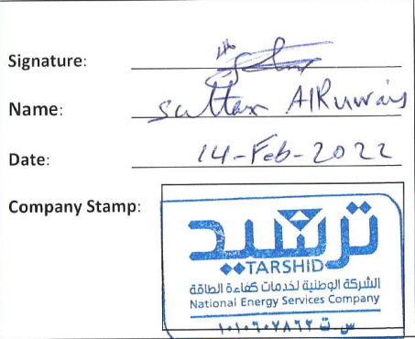  Signature: ________________________________  Name: ________________________________  Date: ________________________________  Company Stamp:
 | Not Approved
Coop Advisor ________________________________
Signature: ________________________________
Date: ________________________________

